## 数据插值

>> x=[0,3,5,7,9,11,12,13,14,15];

>> y=[0,1.2,1.7,2.0,2.1,2.0,1.8,1.2,1.0,1.6];

>> x1=0:0.1:15;

>> y1=interp1(x,y,x1,'spline');

>> plot(x1,y1)

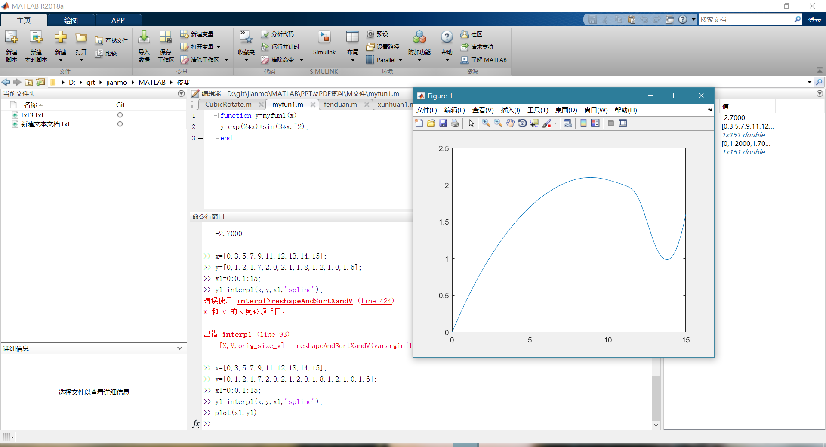

>> clear

>> x=1790:10:2010;

>> y=[3.9,5.3,7.2,9.6,12.9,17.1,23.2,31.4,38.6,

50.2,63.0,76.0,92.0,105.7,122.8,131.7,

150.7,179.3,203.2,226.5,248.7,281.4,308.7];

要串联的数组的维度不一致。

>> y=[3.9,5.3,7.2,9.6,12.9,17.1,23.2,31.4,38.6,

50.2,63.0,76.0,92.0,105.7,122.8,131.7,

150.7,179.3,203.2,226.5,248.7,281.4,308.7];

要串联的数组的维度不一致。

>> y=[3.9 5.3 7.2 9.6 12.9 17.1 23.2 31.4 38.6

50.2 63.0 76.0 92.0 105.7 122.8 131.7

150.7 179.3 203.2 226.5 248.7 281.4 308.7];

要串联的数组的维度不一致。

>> y=[3.9 5.3 7.2 9.6 12.9 17.1 23.2 31.4 38.6 50.2 63.0 76.0 92.0 105.7 122.8 131.7 150.7 179.3 203.2 226.5 248.7 281.4 308.7];

>> ploy(x,y,'*');

未定义函数或变量 'ploy'。

>> plot(x,y,'*');

>> p=polyfit(x,y,3);

警告: 多项式未正确设置条件。请添加具有不同 X 值的点，减少多项式的阶数，或者尝试按照 HELP POLYFIT 中所述进行居中和缩放。

> In polyfit (line 79)

>> polyval(p,2020)

ans =

339.7869

>> plot(x,y,'*',x,ployval(p,x));

未定义函数或变量 'ployval'。

是不是想输入:

>> plot(x,y,'*',x,polyval(p,x));

>>

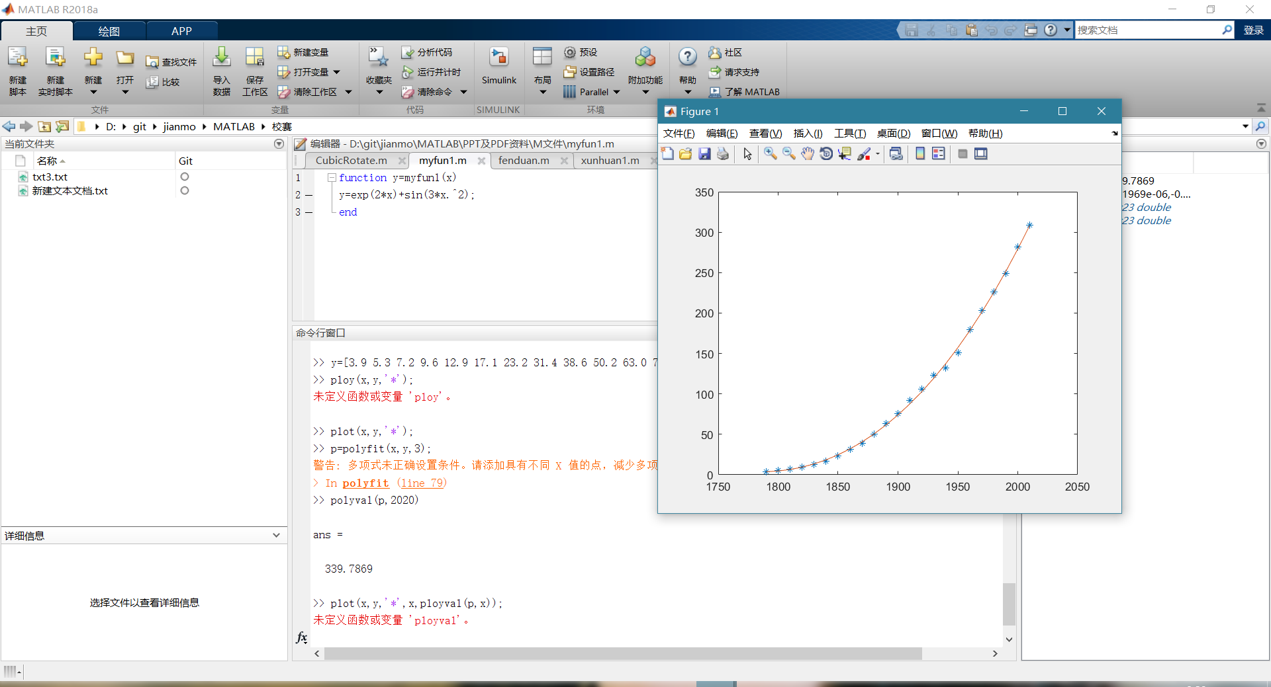

>> clear

>> x=[0.6,1.0,1.4,1.8,2.2,2.6,3.0,3.4,3.8,4];

>> y=[0.08,0.22,0.31,0.4,0.48,0.56,0.67,0.75,0.8,1.0];

>> p=polyfit(x,y,1)

p =

0.2390 -0.0418

>> plot(x,y,'*',x,polyval(p,x))

